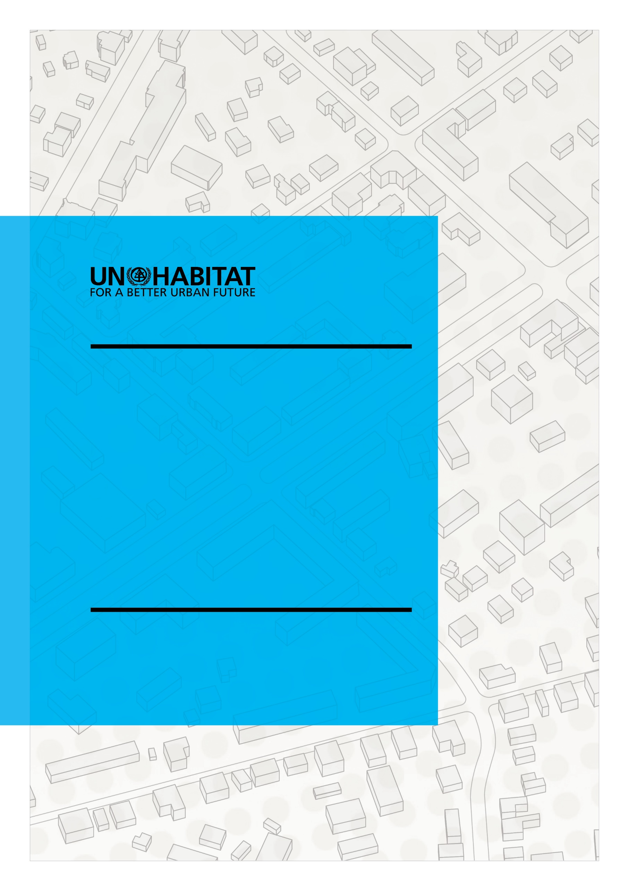
March, 2022 Version

PRC PROJECT DOCUMENT TEMPLATE

PROJECT/PROGRAMME TITLE:

PRC PROJECT STAGE: CONCEPT or FULL PROJECT
(Choose one)

Table of Contents
1 Project Summary 4
1.1 Project Information 4
1.2 Links to the SDGs 5
1.3 Links to the New Urban Agenda 5
1.4 Link to the Strategic Plan 2020 - 2023 5
1.5 Results Framework: relevant indicators 6
1.6 Links to UN-Habitat’s Annual Workprogrammes and Budget 6
1.7 Alignment with UN reform 7
1.8 Basic Project information 7
1.9 Executive summary of the project 8
2 Full project document 8
2.1 Problem and Situation Analysis 8
2.2 Stakeholder analysis and capacity assessment 8
2.3 Lesson Learned (Link to Evaluation report data base) 8
3 Project Implementation methodology/strategy 8
3.1 Project Methodology 8
3.2 Logical framework 8
3.3 Stakeholders (Internal, External and Others) 10
3.4 Strategic alignment / Relevance to the UN Agency 10
4 Social Inclusion Issues, Cross Cutting Thematic Areas, Environmental and Social Safeguards 10
4.1 Social Inclusion Issues 10
4.1.1 Human Rights Analysis and Strategy 10
4.1.2 Gender Analysis and Equality and Women’s Empowerment Strategy 11
4.1.3 Children, Youth and Older Persons Analysis and Strategy 11
4.1.4 Disability Analysis and Strategy 11
4.2 Cross Cutting Thematic Area 11
4.2.1 Resilience Analysis and Strategy 11
4.2.2 Safety Analysis and Strategy 11
4.3 ESSS Principles 11
4.4 Risk Category 12
5 Project Management 12
5.1 Annual Workplan 12
5.2 Coordination arrangements (with internal and external stakeholders) 12
5.3 Governance arrangements 12
5.4 Resource Mobilization 12
5.5 Sustainability and exit Strategy 12
5.6 Project Replication and Scaling up 13
5.7 Risk Management (Including Risk Analysis table) 13
5.8 Monitoring Plan and Reporting Strategy 13
5.9 Budget and staffing table 13
6 Evaluation 13
6.1 Evaluation Plan 13
6.2 Advocacy, Communication and Outreach plan 13
6.3 Knowledge Management and lessons learned 13
6.4 Innovation 13
6.5 Capacity Building (link with UN-Habitat’s Capacity Building Strategy) 13
7 Project Review Committee (PRC) Approvals 14
Annexes 14

Project Document

For Concept Notes: please complete sections 1,2,3,4, and attach Theory of Change & ESSS Screening report
For Project Documents: please complete all the sections below and attach all the required annexes

Project Summary
Preamble
The Project Summary section captures all essential information of UN-Habitat projects. Some if this information is mandatory in IPMR, some additional critical information will be stored outside IPMR. This allows a bird’s eye view during the approval process, allows to identify the linkages with UN-Habitat instruments (ex. Strategic Plan, Work Programme and Budget, Results Framework, ESSS, etc.) and contributes to our capacity to analyse UN-Habitat’s portfolio against our Strategic Plan.

The Project Summary section must be completed for any project, even when using the donor’s template.

IMPORTANT NOTE: the sections highlighted in blue are part of the sections required in IPMR.

Project Information

Project Title
Project Number (from IPMR) | {projectNumber} (complete this section only if the project has already been created in IPMR)
Project Objective

Project Outcomes | Outcome 1:  Indicators  Outcome 2:  Indicators  Outcome 3:  Indicators  Add any additional outcomes

Links to the SDGs
Tag & rank each Outcome against the SDG, at target level. The full list of SDGs & their targets can be found here
OUTCOME 1 |  | SDG1 | SDG2 | SDG3 | SDG4 | SDG5 | SDG6 | SDG7 | SDG8 | SDG9
 | Targets
 |  | SDG10 | SDG11 | SDG12 | SDG13 | SDG14 | SDG15 | SDG16 | SDG17
 | Targets

OUTCOME 2 |  | SDG1 | SDG2 | SDG3 | SDG4 | SDG5 | SDG6 | SDG7 | SDG8 | SDG9
 | Targets
 |  | SDG10 | SDG11 | SDG12 | SDG13 | SDG14 | SDG15 | SDG16 | SDG17
 | Targets

OUTCOME 3 |  | SDG1 | SDG2 | SDG3 | SDG4 | SDG5 | SDG6 | SDG7 | SDG8 | SDG9
 | Targets
 |  | SDG10 | SDG11 | SDG12 | SDG13 | SDG14 | SDG15 | SDG16 | SDG17
 | Targets

(Please copy and paste the tables for the additional outcomes, if any)

Links to the New Urban Agenda
Please copy below the paragraphs of the NUA your project is linking to.
The New Urban Agenda is accessible here.
In the New Urban Agenda Illustrated Handbook, the NUA paragraphs are being referred to by theme.

Link to the Strategic Plan 2020 - 2023
Rank each Project Outcome against Subprogramme outcomes.
The List of Subprogramme Outcomes can be found here (summary on page 82).

0 = no contribution 1 = primary outcome (direct contribution), 2 = secondary outcome (indirect, partial contribution)

The planned budget distribution should be rounded up to 5% focusing on the main subprogrammes.

 | Subprogramme 1 |  |  | Subprogramme 2 |  |  | Subprogramme 3 |  |  | Subprogramme 4
 | 1.1 | 1.2 | 1.3 | 2.1 | 2.2 | 2.3 | 3.1 | 3.2 | 3.3 | 4.1 | 4.2 | 4.3
Out. 1 | 0 | 0 | 0 | 0 | 0 | 0 | 0 | 0 | 0 | 0 | 0 | 0
Out. 2 | 0 | 0 | 0 | 0 | 0 | 0 | 0 | 0 | 0 | 0 | 0 | 0
Out. 3 | 0 | 0 | 0 | 0 | 0 | 0 | 0 | 0 | 0 | 0 | 0 | 0
[…] | 0 | 0 | 0 | 0 | 0 | 0 | 0 | 0 | 0 | 0 | 0 | 0
Planned budget distribution | X % |  |  | X % |  |  | X % |  |  | X %

Projection of budget towards
Gender Equality
X%

Cross-cutting thematic areas & Social inclusion issues (several options possible)
☐ Human Rights ☐ Gender ☐ Children, Youth and Older persons ☐ Disability
☐ Resilience ☐ Safety

Related UNH Communities of practice (several options possible)
☐ CoP Land, Housing and Shelter ☐CoP Human rights & Social Inclusion
☐ CoP Urban Basic Services ☐ CoP Planning, Finance and Economy
☐ CoP Climate Change ☐ CoP Policy, Legislation & Governance

ESSS Overview

Risk category of the project
Please select below what is the risk category resulting from the ESSS Screening Report. Please nsure to open this document on the app.

Choose an item.

Overview of the ESSS Principles on which the project might have an impact
☐ P1: Labour and working conditions
☐ P2: Zero-carbon development, Pollution prevention and resource efficiency
☐ P3: Climate Change, community health, safety and security
☐ P4: Displacement and involuntary resettlement
☐ P5: Biodiversity conservation and sustainable management of living natural resources
☐ P6: Indigenous people
☐ P7: Cultural Heritage
☐ P8: Compliance with law

Results Framework: Relevant indicators to be monitored
Select the section of the Results Framework (RF) in the first column and complete the indicators in the second column.
Core indicators are highlighted in the Results Framework here .
Section of the RF  (Please select) | Indicator(s)  (Please complete according to RF) | Comment
Choose an item
Choose an item
Choose an item
Choose an item
Choose an item
Choose an item
Choose an item

Links to UN-Habitat’s Annual Work programmes and Budget
Please, complete the deliverables that the project will cover, as described in UN-Habitat’s Work programme and Budget for the relevant years.

Indicate year | Subprogramme No. | Deliverables | Details | Quantity
 | Choose an item. | Choose an item.
 | Choose an item. | Choose an item.
 | Choose an item. | Choose an item.
 | Choose an item. | Choose an item.
 | Choose an item. | Choose an item.
 | Choose an item. | Choose an item.
 | Choose an item. | Choose an item.
 | Choose an item. | Choose an item.

Alignment with UN reform
Delivery on relevant EAs/outcomes of UNSDCFs
Collaborating UN Agencies

Basic Project information
Project Type | Choose an item.
Project Scale | Choose an item.
Location (main)
Countries/Regions
Responsible UN-Habitat office (leading office)
Other collaborating UN-Habitat offices
Target group(s)

External partner(s)

Project Manager
Programme Management Officer (PMO)
Estimated Start and End Dates

Actual Start and End Dates
Overall budget / Total project budget
(in USD only)
Sources of funding/Contributions  (add lines if multiple donors) | Donor(s) | Financial | In Kind | Programme Support (%)
 | UN-HABITAT
Third Party/Other:
Please specify here
 | Total: |  | In kind:
Funds to be secured
(Budget – Total Contributions)
Potential Donor(s)

Executive summary of the project
(Description, Approach and Main Expected Accomplishment)

Full project document
IMPORTANT NOTE – sections/fields highlighted in blue are part of the sections in IPMR

Problem and Situation Analysis
Identifies key problems (of the target groups and final beneficiaries), constraints, opportunities and risks, which determine cause and effect relationships.
Problem/situation analysis should include gender, youth and human right situation

Stakeholder analysis and capacity assessment
Capacity assessment of relevant stakeholders – Provide a short summary of government
agency/legal environment in which the project operates, as well as resource capacity of
Government/other actors.
Stakeholders include: Agencies, organizations, groups, or individuals who have a direct or
indirect interest in the intervention or its evaluation.

Lesson Learned (Link to Evaluation report data base)

Project Implementation methodology/strategy
IMPORTANT NOTE – sections/fields highlighted in blue are part of the sections in IPMR
Please find here the link to the Catalog of services, providing the normative tools available.

Detailed step-by-step description of how Project will be Implemented

Logical framework
RESULTS | Indicators | Risks  (which could prevent the achievement of the objective/outcome/output/…)
Objective: | Indicator:  Means of Verification:  Interval:  Baseline:  Target:  Interim targets:  Description:  Interval:  Value: | Risk:  Impact:  Mitigation Plan:
Outcome | Indicator:  Means of Verification:  Interval:  Baseline:  Target:  Interim targets:  Description:  Interval:  Value: | Risk:  Impact:  Mitigation Plan:
Output | Indicator:  Means of Verification:  Interval:  Baseline:  Target:  Interim targets:  Description:  Interval:  Value: | Risk:  Impact:  Mitigation Plan:
Activity

Stakeholders (Internal, External and Others)
Agencies, organisations, groups or individuals who have a direct or indirect interest in the intervention or its evaluation.

Strategic alignment / Relevance to the UN Agency

Social Inclusion Issues, Cross Cutting Thematic Areas, Environmental and Social Safeguards
IMPORTANT NOTE – sections/fields highlighted in blue are part of the sections in IPMR
At the Concept Note stage, the Screening Report should be attached.
At the ProDoc stage, the Screening Report and Scoping Report should be attached.

More info on the ESSS as well as templates for the Screening and Scoping Report can be found here.

Social Inclusion Issues

Human Rights

Describe the issue identified in the project

Identify risks and impacts – overview (the details are provided in the Screening report)
Marker: Choose an item.

Management of the risks (methodology & monitoring)

Gender
Please find the policy here
Describe the issue in the project

Identify risks and impacts – overview (the details are provided in the Screening report)

Management of the risks (methodology & monitoring)

Children, Youth and Older Persons

Describe the issue in the project

Identify risks and impacts – overview (the details are provided in the Screening report)

Management of the risks (methodology & monitoring)

Disability

Describe the issue in the project

Identify risks and impacts – overview (the details are provided in the Screening report)

Management of the risks (methodology & monitoring)

Cross-Cutting Thematic Areas

Resilience

Marker: Choose an item.

Risks triggered

Safety

Risks triggered

ESSS Principles

This section describes the ESSS principles that were triggered during the completion of the Screening (project concept note) and Scoping (project proposal) Report from the 9 principles listed in the ESSS 3.0. Please refer to the ESSS Screening or Scoping Report for further details.

Principles | Brief description of risks and impacts regarding the triggered Principle, if not triggered insert n/a and explain why
Principle 1: Labour and Working Conditions
Principle 2: Pollution Prevention and Resource Efficiency
Principle 3: Community Health, Safety and Security
Principle 4: Displacement and Involuntary Resettlements
Principle 5: Biodiversity, Conservation and Sustainable Management of Living Natural Resources
Principle 6: Indigenous Peoples
Principle 7: Cultural Heritage
Principle 8: Compliance with the Law
Principle 9: Access and Spatial Justice

Project Management
IMPORTANT NOTE – sections/fields highlighted in blue are part of the sections in IPMR

Detailed Project Annual Workplan

Coordination arrangements (with internal and external stakeholders)
Any formal or informal arrangements that the project is entering into with relevant stakeholders in order to ensure progress toward the project objective.

Governance arrangements
Formal arrangements with national counterparts, end beneficiaries, funding partners to provide overall guidance for project implementation.

Resource Mobilization
Please find UNH Resource Mobilization Strategy here

Sustainability and exit Strategy
Please describe below the mechanisms in place to ensure that the gains from the project are sustainable even after the project is completed.

Project Replication and Scaling up

Risk Management (Including Risk Analysis table)
Please describe here the measures in place to manage the risks identified in the logframe.

Monitoring Plan and Reporting Strategy
The plan should describe the methodology used to monitor the indicated in the logframe.
Please find here the UNH Results Based Management Policy

Budget and staffing table

Evaluation
IMPORTANT NOTE – sections/fields highlighted in blue are part of the sections in IPMR

Evaluation Plan
Please find here UNH Evaluation Policy and UNH Evaluation Manual here

Advocacy, Communication and Outreach plan
Please find the Donor Visibility Guideline here

Knowledge Management and lessons learned

Innovation
Please, find here the guidance note on Fostering Innovation in urban programmes and projects

Capacity Building (link with UN-Habitat’s Capacity Building Strategy)
Please find here the CB strategy as well as the...

Project Team

 | Names | Level | Role | Part of the House | Contribution | % of staff time
- Project Manager |  | P5 | Lead | Nairobi  Urban Basic services/ urban Planning | In-kind  (SIDA Funds) | 10% of staff time
- Other members of project team |  | P4 | Project technical team |  | In-kind,  UNV | 25% of staff time
 |  | P4 | Project technical team |  | In-kind,  PSC | 10% of staff time
 |  | P3 | Project technical team |  | In-kind, | 25% of staff time
- Supervisor of Project Manager |  | D1 | Director, |  | In-kind,) | 5% of staff time
- Person(s) who formulated the ProDoc | , | P5, P4 & P3 | Project technical team supporting UNHABITAT activities for this project |  | In-kind | 10% of staff time for Takehiro and 25% for the others

Checklists of Documents to be Submitted
This template should be attached as a Word document.
All the annexes should be uploaded or attached as pdf, with the exception of Annex D and the ESSS reports.

Checklist of documents to be submitted to the PRC Working Group at Concept Note stage:
☐ Current template – with sections 1,2,3 & 4 completed
☐ ESSS Screening Report – completed
☐ Annex 1a: Project Team's response to recommendations made during CONCEPT co-creation –signed by team leader
☐ Theory of Change (no Template)

Checklist of documents to be submitted to the PRC Working Group at full Prodoc stage:
☐ Current Project template – with all the sections completed
☐ Theory of Change (no Template)
☐ Project budget (use UN-Habitat budget template)
☐ Detailed Project Annual WorkPlan
☐ Staffing table (No template-guidance from MACS)
☐ Staff Terms of Reference (No template-to be created by project teams)
☐ Annex 1b: Response to PRC recommendations at Concept – signed by team leader
☐ Annex D: Project Submission Checklist – signed by team leader, PMO, submitting branch leader or regional representative, chief of Urban Practices Branch or Regional Programme Division, and chief of Programme Development Branch
☐ ESSS Screening Report – reviewed and endorsed
☐ ESSS Scoping Report – completed (if project risk falls under categories A, B1, B2, or C)
☐ ESIA report – completed (if project is high risk A or B1) OR ESAP (project low risk B2, C & E)
(for projects in category D, no ESIA or ESAP to be submitted)

Final approval:
☐ Annex 2: Teams Reponses to PRC WG inputs – completed and signed by the team leader, PRC WG Secretary, and PRC WG Chair (this template may vary whether the project is reviewed by PRC-HQ WG or any of the LWG).

Project team members can be staff and/or consultants.
Supervisor must be a UNEP staff member, not a consultant.

